Apoorva Vinod 1NT18IS205
Big Data Lab 05.05.2021

Tasks:

1.Create a directory named by your name
2.Add two empty files into it
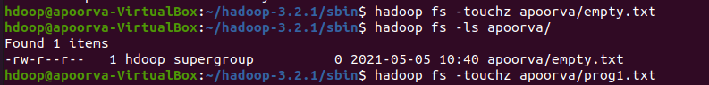
3.List all the files in the directory that you have created
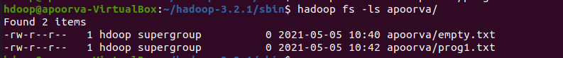
4.Create one more directory by your usn and put that inside the directory of your name
5.Create a file in your local system by the name_usn.txt and add the contents as “Syntax to list ls command is hadoop fs –ls “
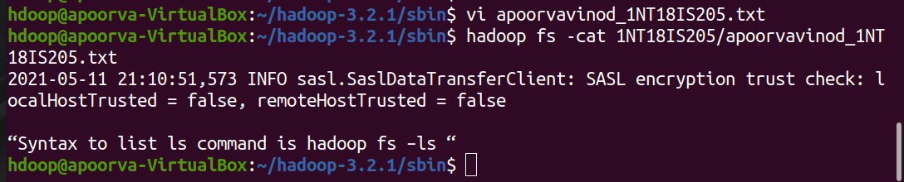
6.Put the file usn_name.txt in your hdfs directory called usn
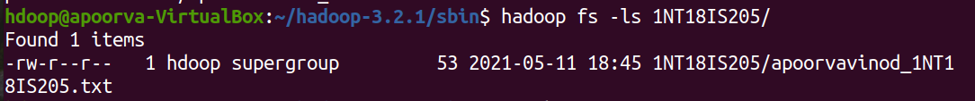

7.Put empty file of hdfs into the local file system
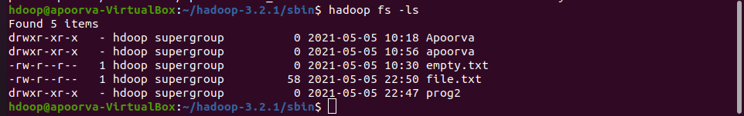
8. Use mv command to move files from local file system and hdfs file system
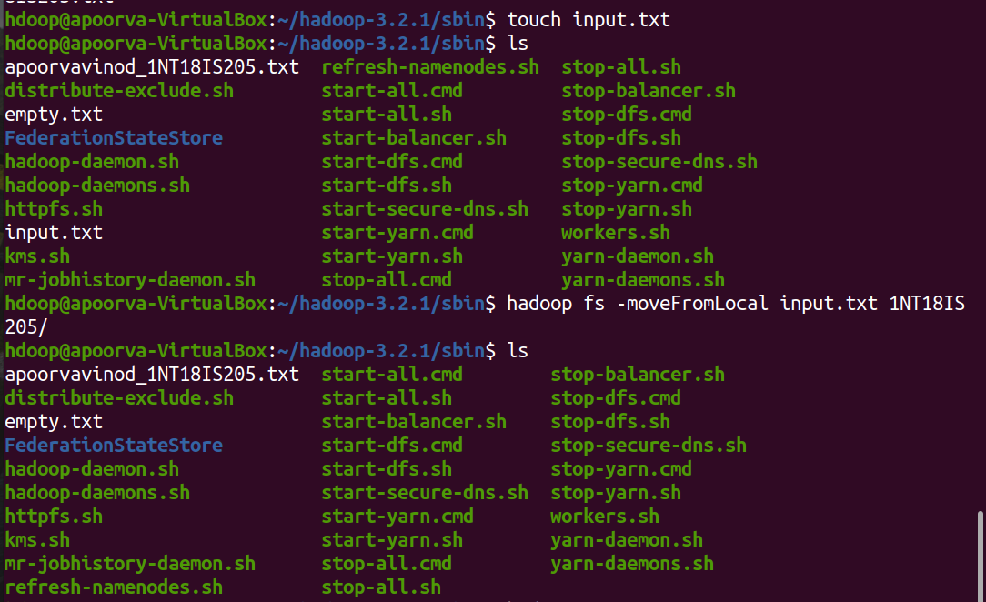
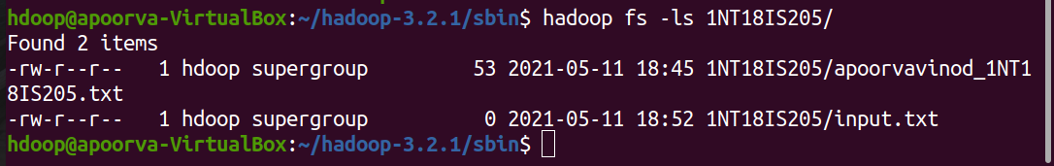

9. Experiment of cp command of hadoop
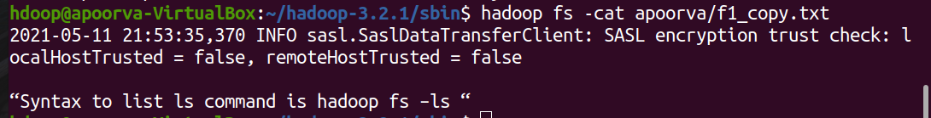
10. Display the total size of all the files in name directory
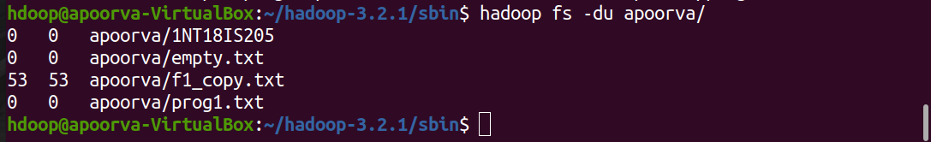
11. Display each file size in usn directory
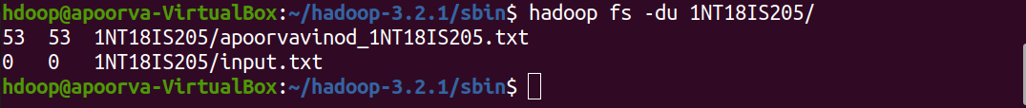
12. Use stat command on name and usn directories

13. Illustrate the use of append command
